**When it isnt sunny, we dont see any butterflies.**

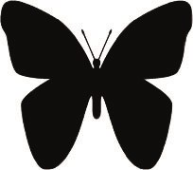

**The butterfly didnt fly away.**



**Its a butterfly!**



**Thats the first butterfly Ive seen.**



**Were going to put bird feeders in our garden.**

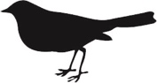

**If we dont make a noise, the bird wont fly away.**



**I cant hear the bird sing.**



**The cow didnt want to go out of the field.**

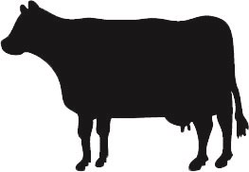

**I havent seen this cow before.**



**Were going to milk the cow this morning.**



**Im going to look for a crab in this pool.**

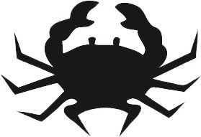

**You shouldnt pick up a crab or it might pinch you.**



**Crabs dont like to be out of the water.**



**Well take the dog for a walk if it doesnt rain.**

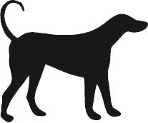

**My dog hasnt had any dinner.**



**The dog wouldnt bark when it saw a cat.**



**Shes getting a dog for her birthday.**



**The little cat wouldnt miaow.**

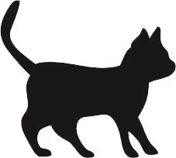

**Theyve got a cat to scare the mice away.**



**The cat thats in the garden is called Tibby.**



**Bats wont come out in the daytime.**

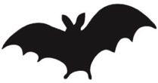

**If they go out this evening, theyll see some bats.**



**That isnt a bird, its a bat!**



**The frog didnt jump in the pond.**

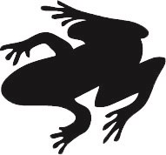

**Frogs cant run but they can jump.**



**Weve got a frog in our garden pond.**



**Im going to get a pet rabbit.**

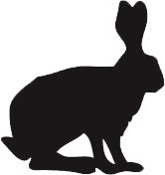

**The rabbits hadnt seen the sly fox.**



**There arent any rabbits in this field.**



**It isnt a dog, its a fox.**

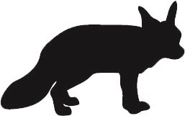

**She didnt see the fox when it hid in the trees.**



**The fox wouldnt come out in the daytime.**



**Fish havent got legs but they have got fins.**

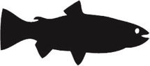

**He didnt catch any fish today.**



**Theres a big fish in the pond.**



**When they went to the zoo, they didnt see any monkeys.**

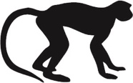

**The monkeys wouldnt come down from the trees.**



**Thats the monkeys making all the noise.**



**Shes going to the zoo to see the penguins.**

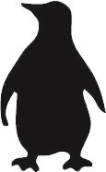

**Penguins dont go far from the sea.**



**A penguin is a bird but it cant fly.**



**The goat wouldnt go across the bridge.**

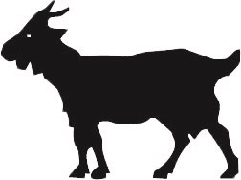

**There arent any goats on this farm.**



**The farmer didnt forget to feed his goats.**



**Shes the little red hen that lives on the farm.**

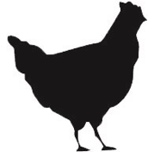

**The hens werent in the farmyard. .**



**The hen didnt lay any eggs today.**

