**The bat flew in the night sky.**

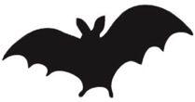

**Our milk came from the cows.**

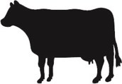

**When it was spring, we saw butterflies.**

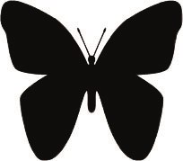

**The crab was in a rock pool.**

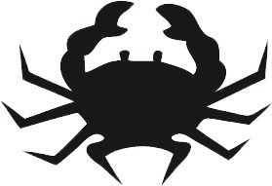

**In the morning, the birds were singing.**

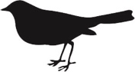

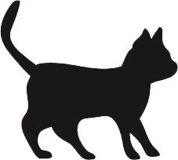

**I could hear the frogs croaking.**

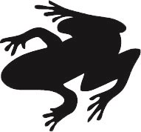

**The cat was sleeping by the fire.**

**The dog wagged its tail.**

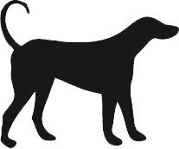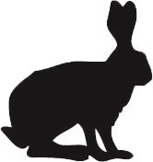

**The rabbits lived in a burrow.**

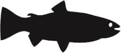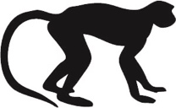

**The fish were swimming in the river.**

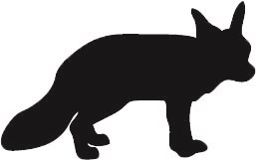

**We went to the zoo to see the monkeys.**

**When the fox saw the dog, it ran away.**

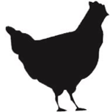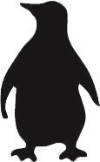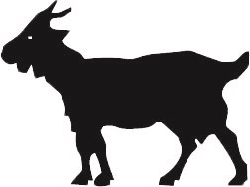

**The hens pecked the seed in the farmyard.**

**In the field there lived a little goat.**

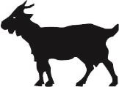

**The penguins did not mind the cold.**