**The bat flew in the night sky.**

**The bat in the night sky.**

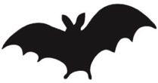

**Our milk came from the cows.**

**Our milk from the cows.**

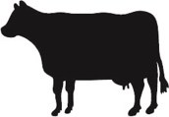

**When it was spring, we saw butterflies.**

**When it spring, we butterflies.**

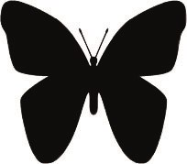

**The crab was in a rock pool.**

**The crab in a rock pool.**

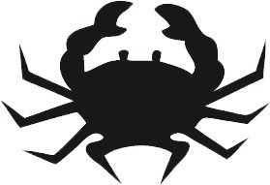

**In the morning, the birds were singing.**

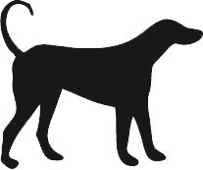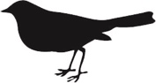

**I could hear the frogs croaking.**

**I hear the frogs croaking.**

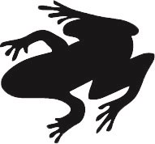

**The cat sleeping by the fire.**

**The cat was sleeping by the fire.**

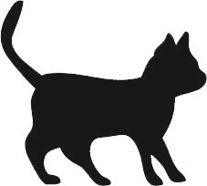

**The dog wagged its tail.**

**The dog its tail.**

**The cat sleeping by the fire.**

**In the morning, the birds singing.**

**The rabbits lived in a burrow.**

**The rabbits in a burrow.**

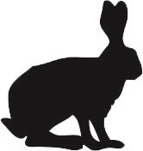

**We went to the zoo to see the monkeys.**

**We to the zoo to see the monkeys.**

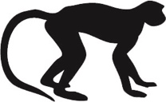

**The fish were swimming in the river.**

**The fish swimming in the river.**

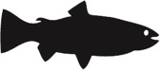

**When the fox saw the dog, it ran away.**

**When the fox the dog, it away.**

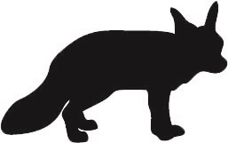

**The hens pecked the seed in the farmyard.**

**The hens the seed in the farmyard.**

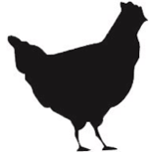

**In the field there lived a little goat.**

**In the field there a little goat.**

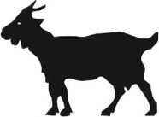

**The penguins did not mind the cold.**

**The penguins not mind the cold.**

