**I see a bat when I go out at night.**

**I a bat when I out at night.**

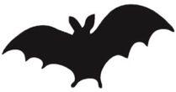

**The cow is in the field. She eats the grass.**

**The cow in the field. She the grass**

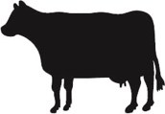

**The butterflies flap their wings and dance around the flowers.**

**The butterflies their wings and around the flowers.**

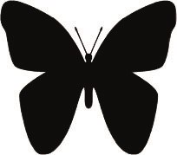

**We go to the beach and we catch a crab.**

**We to the beach and we a crab.**

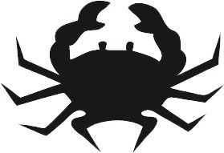

**The birds are singing in the trees.**

**The birds singing in the trees.**

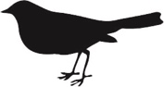

**The frog is hopping by the pond.**

**The frog hopping by the pond.**

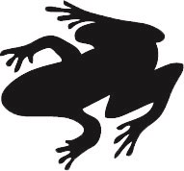

**We have a little cat and it likes milk.**

**We a little cat and it milk.**

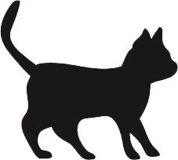

**The dog is barking and it runs down the path.**

**The dog barking and it down the path.**

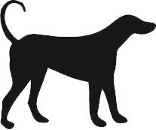

**The rabbits have not seen the fox.**

**The rabbits not seen the fox.**

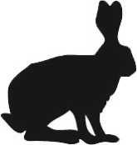

**The monkey swings in the tree.**

**The monkey in the tree.**

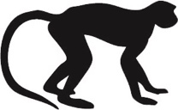

**I swim in the sea and I see a fish.**

**I in the sea and I a fish.**

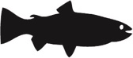

**The little fox is playing near its den.**

**The little fox playing near its den.**

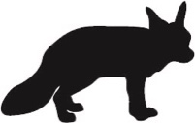

**The hen lays an egg for my breakfast.**

**The hen an egg for my breakfast.**

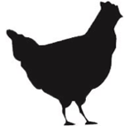

**The goat is going over the bridge.**

**The goat going over the bridge.**

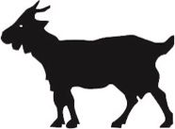

**The penguins are eating fish.**

**The penguins eating fish.**

