**I can _____ a dog barking.**

**here**

**hear**

**Letters**

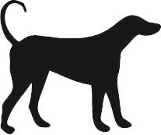

**When my cat wants to go out, I can _______ her say miaow.**

**here**

**hear**

**Letters**

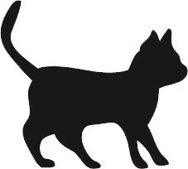

**This is the dog’s home. He lives _____ .**

**here**

**hear**

**Letters**



**This is my cat’s bed. She sleeps _______.**

**here**

**hear**

**Letters**



**The bat is very quiet. I can’t ________ it when it flutters about.**

**here**

**hear**

**Letters**

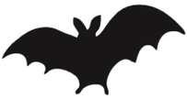

**I wonder if there are any bats in _________ .**

**here**

**hear**

**Letters**



**The children could ________ a frog croaking.**

**here**

**hear**

**Letters**

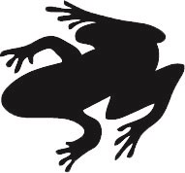

**There is a pond near _______ that has lots of frogs in it.**

**here**

**hear**

**Letters**



**The rabbits could _______ the fox.**

**here**

**hear**

**Letters**

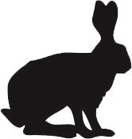

**The rabbits live in a field near ________.**

**here**

**hear**

**Letters**



**The fox stopped running. He could ________ a dog.**

**here**

**hear**

**Letters**

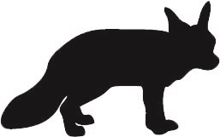

**This is a den. The fox cubs live in _________ .**

**here**

**hear**

**Letters**



**When I woke up I could _______ the birds singing.**

**here**

**hear**

**Letters**

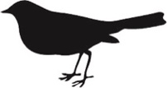

**The bird has made a nest in ________.**

**here**

**hear**

**Letters**



**I can _______ the cows when they moo.**

**here**

**hear**

**Letters**

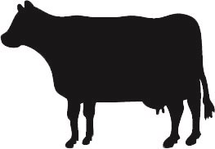

**The cow is ________ in the field.**

**here**

**hear**

**Letters**



**I could ______ the penguins when I went to the zoo.**

**here**

**hear**

**Letters**

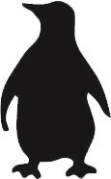

**There aren’t any penguins _______.**

**here**

**hear**

**Letters**



**I could not ______ the butterflies because they did not make a noise.**

**here**

**hear**

**Letters**

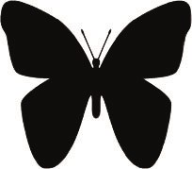

**The butterflies are _______ on the flowers.**

**here**

**hear**

**Letters**



**I could ______ the splash when a fish jumped out of the water.**

**here**

**hear**

**Letters**

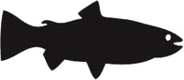

**The fish is ______ in the pond.**

**here**

**hear**

**Letters**



**I could _______ the monkeys chattering in the trees.**

**here**

**hear**

**Letters**

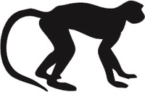

**The monkeys were running _______ and there.**

**here**

**hear**

**Letters**



**When the hen lays an egg, I can ______ her cluck.**

**here**

**hear**

**Letters**

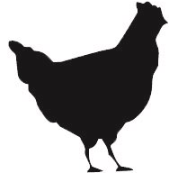

**I can ______ the sea. We can look for a crab on the beach.**

**here**

**hear**

**Letters**

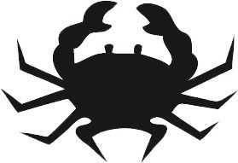

**There is a crab _______ in the pool.**

**here**

**hear**

**Letters**



**The hen lives ______ , in my garden.**

**here**

**hear**

**Letters**



**The little goats could _______ the mummy goat.**

**here**

**hear**

**Letters**

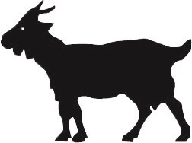

**The goat is _______ in the field.**

**here**

**hear**

**Letters**

