**________ has my dog gone?**

**we’re**

**where**

**were**

**Letters**

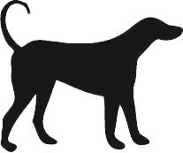



**The mice _______ hiding and the cat was looking for them.**

**we’re**

**where**

**were**

**Letters**

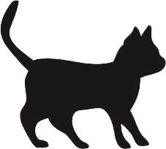

**When we move house, ______ going to get a pet cat.**

**we’re**

**where**

**were**

**Letters**



**This is ______ my cat likes to sit.**

**we’re**

**where**

**were**

**Letters**



**The two dogs _______ barking when they saw the cat.**

**we’re**

**where**

**were**

**Letters**

**________ going to take the dog for a walk.**

**we’re**

**where**

**were**

**Letters**



**When we go for a walk tonight, ________ going to look out for bats.**

**we’re**

**where**

**were**

**Letters**

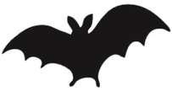

**_______ do bats go in the**

**daytime?**

**we’re**

**where**

**were**

**Letters**



**The bats ______ flying around the roofs of the houses.**

**we’re**

**where**

**were**

**Letters**



**______ going to the pond to see if there are any frogs.**

**we’re**

**where**

**were**

**Letters**

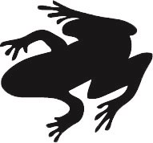

**______ is the frog that I can hear croaking?**

**we’re**

**where**

**were**

**Letters**



**The frogs ______ sitting on the lily pads in the pond.**

**we’re**

**where**

**were**

**Letters**



**The wood _______ the foxes lived was on the side of the hill.**

**we’re**

**where**

**were**

**Letters**

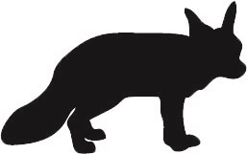

**_______ not sure if it is a fox or a dog.**

**we’re**

**where**

**were**

**Letters**



**The little foxes _______ playing with each other.**

**we’re**

**where**

**were**

**Letters**



**When it is spring, _______ going to count the birds we see in our garden.**

**we’re**

**where**

**were**

**Letters**

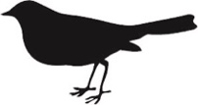

**______ do those birds make their nests?**

**we’re**

**where**

**were**

**Letters**



**The birds _______ looking for worms in the field.**

**we’re**

**where**

**were**

**Letters**



**When we visit the farm ______ going to watch the farmer milk the cows.**

**we’re**

**where**

**were**

**Letters**

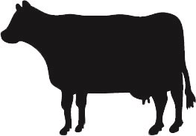

**The penguins ________ swimming in the icy water.**

**we’re**

**where**

**were**

**Letters**

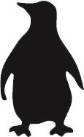

**The Antarctic is ________ lots of penguins live.**

**we’re**

**where**

**were**

**Letters**



**When ______ at the zoo, we will see the penguins being fed.**

**we’re**

**where**

**were**

**Letters**



**This is the barn _______ the farmer keeps the cows.**

**we’re**

**where**

**were**

**Letters**



**The cows ________ in the field with the horses.**

**we’re**

**where**

**were**

**Letters**



**When it is sunny, _______ going to see lots of butterflies**

**we’re**

**where**

**were**

**Letters**

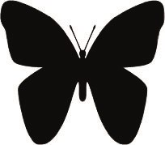

**_______ do butterflies go in the winter?**

**we’re**

**where**

**were**

**Letters**



**The butterflies _______ flying around the flowers.**

**we’re**

**where**

**were**

**Letters**



**_______ going to get a new tank for our fish.**

**we’re**

**where**

**were**

**Letters**

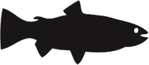

**The deep water is ______ most of the fish live.**

**we’re**

**where**

**were**

**Letters**



**The fish _______ swimming in the stream.**

**we’re**

**where**

**were**

**Letters**



**When ______ at the zoo, we will go to see the monkeys.**

**we’re**

**where**

**were**

**Letters**

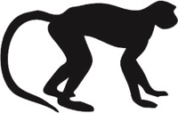

**The rainforest is _______ lots of monkeys live.**

**we’re**

**where**

**were**

**Letters**



**There _______ three monkeys sitting on the roof.**

**we’re**

**where**

**were**

**Letters**



**________ going to see if there are any crabs in this pool.**

**we’re**

**where**

**were**

**Letters**

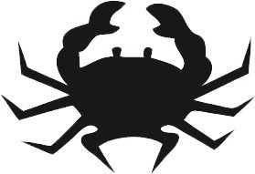

**These are the rock pools ______ lots of crabs live.**

**we’re**

**where**

**were**

**Letters**



**The crabs _______ running across the sandy beach.**

**we’re**

**where**

**were**

**Letters**



**Tomorrow morning, _______ going to see if the hens have laid any eggs.**

**we’re**

**where**

**were**

**Letters**

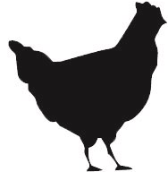

**_______ do the hens sleep when it goes dark?**

**we’re**

**where**

**were**

**Letters**



**The hens ________ pecking in the field.**

**we’re**

**where**

**were**

**Letters**



**_______ reading a story about three goats and a troll.**

**we’re**

**where**

**were**

**Letters**

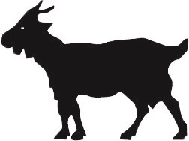

**The goats had to cross the bridge ______ there was a troll.**

**we’re**

**where**

**were**

**Letters**



**On the farm, the children _______ feeding the goats.**

**we’re**

**where**

**were**

**Letters**



**When the sun went down, the rabbits ________ hiding in their holes.**

**we’re**

**where**

**were**

**Letters**

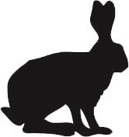

**The rabbits hopped to the field _______ there was lots of grass for them to eat.**

**we’re**

**where**

**were**

**Letters**



**Our pet rabbits _______ eating carrots.**

**we’re**

**where**

**were**

**Letters**

