**The _____ big dogs barked when they heard the noise.**

**to**

**two**

**too**

**Letters**

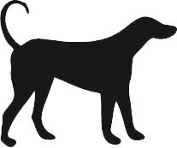

**The cat wanted ____ go out into the garden.**

**to**

**two**

**too**

**Letters**

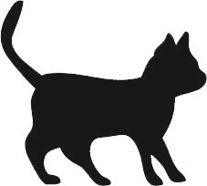

**There are _____ cats sitting on the fence.**

**to**

**two**

**too**

**Letters**



**The mouse is _____ quick for the cat.**

**to**

**two**

**too**

**Letters**



**I take my dog _____ the vet when he is sick.**

**to**

**two**

**too**

**Letters**



**When I go for a walk, my dog comes _____.**

**to**

**two**

**too**

**Letters**



**Moths fly at night and bats do ______.**

**to**

**two**

**too**

**Letters**

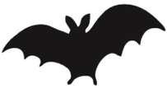

**I saw ______ bats flying in the trees.**

**to**

**two**

**too**

**Letters**



**The bats flew ______ the old house.**

**to**

**two**

**too**

**Letters**



**The duck swam in the pond and the frog did _____.**

**to**

**two**

**too**

**Letters**

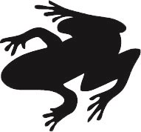

**The frog wanted to get _____ the cool water.**

**to**

**two**

**too**

**Letters**



**I have seen _____ frogs in my garden.**

**to**

**two**

**too**

**Letters**



**The fox was _____ quick for the dog to catch it.**

**to**

**two**

**too**

**Letters**

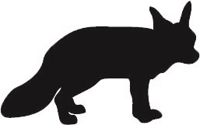

**The ______ baby foxes played in the bushes.**

**to**

**two**

**too**

**Letters**



**The fox tried _____ jump over the fence in the farmyard.**

**to**

**two**

**too**

**Letters**



**The bird was singing but it was _____ noisy to hear it.**

**to**

**two**

**too**

**Letters**

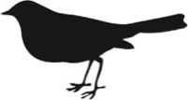

**The bird flew _____ the top of the tree.**

**to**

**two**

**too**

**Letters**



**There were _______ eggs in the bird’s nest.**

**to**

**two**

**too**

**Letters**



**The cow is in the barn and the horse is ______.**

**to**

**two**

**too**

**Letters**

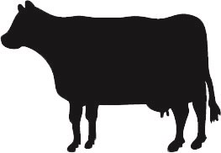

**The penguin swam _____ the floating ice.**

**to**

**two**

**too**

**Letters**

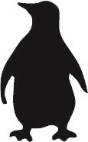

**We saw _______ types of penguin when we went to the zoo.**

**to**

**two**

**too**

**Letters**



**Penguins can live in places where it is ______ cold for other birds.**

**to**

**two**

**too**

**Letters**



**The farmer brought his cows _____ the market.**

**to**

**two**

**too**

**Letters**



**The ______ brown cows sat under the shady tree.**

**to**

**two**

**too**

**Letters**



**Bees like flowers and butterflies do _____**

**to**

**two**

**too**

**Letters**

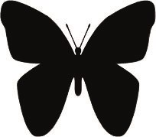

**There were ______ blue butterflies flying around my garden.**

**to**

**two**

**too**

**Letters**



**I am going ______ count all the butterflies that I see**

**to**

**two**

**too**

**Letters**



**The fish was _______ big to catch with the net.**

**to**

**two**

**too**

**Letters**

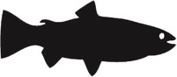

**I have got _______ pet fish in my fish tank.**

**to**

**two**

**too**

**Letters**



**In the river, the fish swim ______ the deep water.**

**to**

**two**

**too**

**Letters**



**One monkey climbed up and the other did _____.**

**to**

**two**

**too**

**Letters**

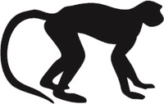

**There were ______ monkeys playing in the trees.**

**to**

**two**

**too**

**Letters**



**The baby monkeys ran ______ their mother.**

**to**

**two**

**too**

**Letters**



**There are _____ many crabs in this pool. We can’t paddle here.**

**to**

**two**

**too**

**Letters**

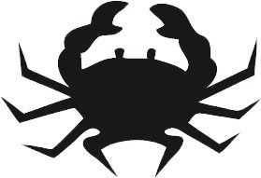

**The little boy had _____ crabs in his bucket.**

**to**

**two**

**too**

**Letters**



**There is a crab _______ in the pool.**

**to**

**two**

**too**

**Letters**



**The hens were in the farmyard and the ducks were _____**

**to**

**two**

**too**

**Letters**

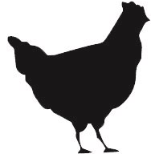

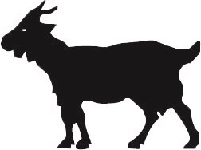

**_____ goats lived in a field near the forest.**

**to**

**two**

**too**

**Letters**

**The little hen laid ______ brown eggs for me.**

**to**

**two**

**too**

**Letters**



**When it’s time for their dinner, the hens come _______ the farmhouse door.**

**to**

**two**

**too**

**Letters**



**The big goat crossed over the bridge and the little one do _____**

**to**

**two**

**too**

**Letters**



**When I have fed the sheep, I am going ______ feed the goats.**

**to**

**two**

**too**

**Letters**



**The mummy rabbit ran away and the baby on did _____.**

**to**

**two**

**too**

**Letters**

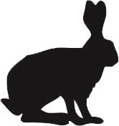

**If we go _____ the park, I will see a rabbit .**

**to**

**two**

**too**

**Letters**



**I have got ______ pet rabbits.**

**to**

**two**

**too**

**Letters**

